## **Lab_Day-7 ANP-C9180 (For Loop)**

**Q1. Print the first 10 natural numbers using for loop .**

**Sol.**

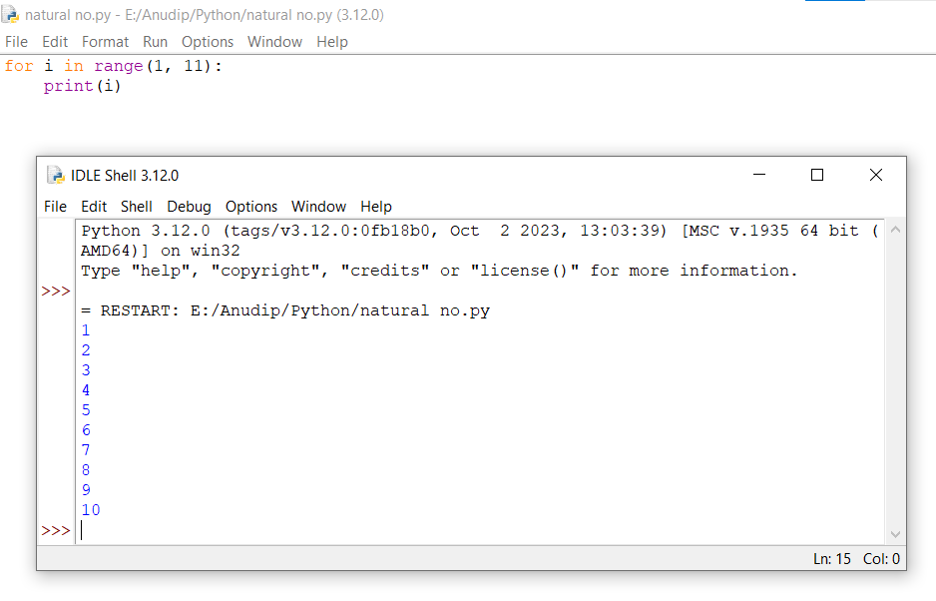

**Q2. Python program to check if the given string is a palindrome**

**Sol.**

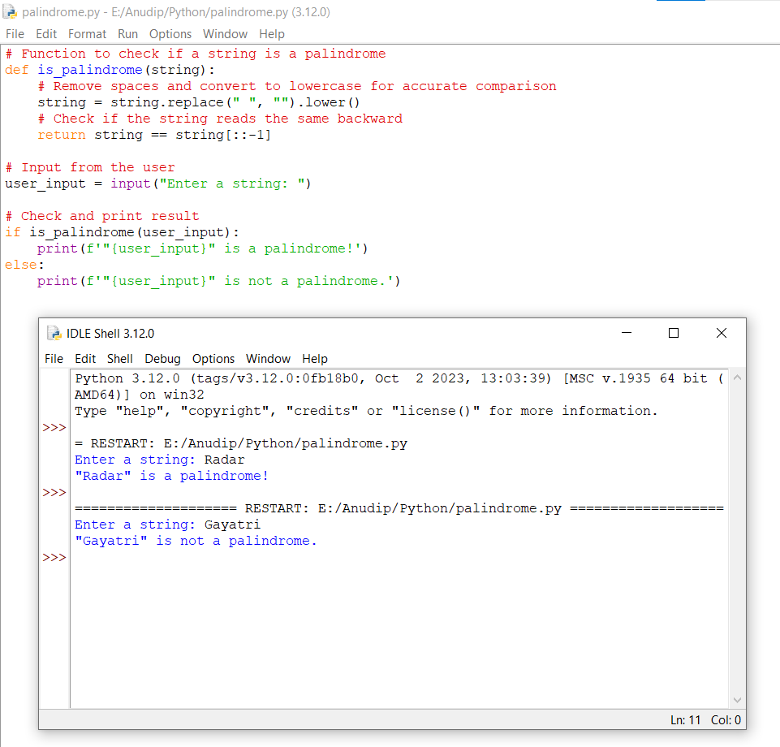

**Q3. Python program to check if a given number is an Armstrong number**

**Sol.**

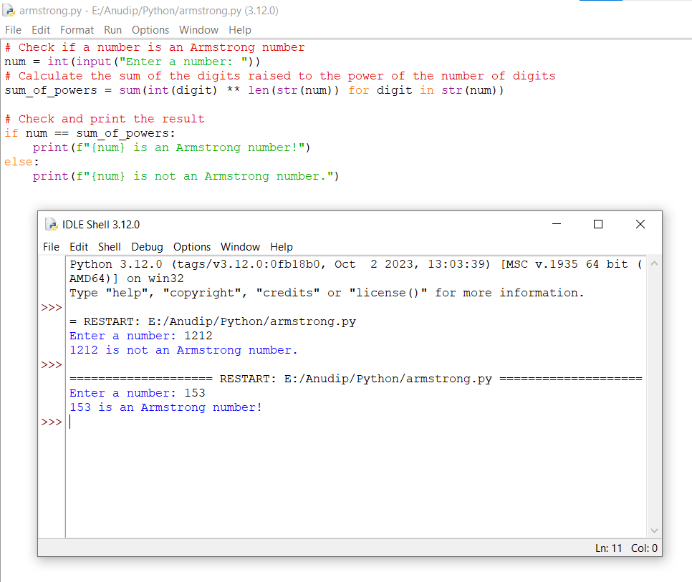

**Q4. Python program to get the Fibonacci series between 0 to 50**

**Sol.**

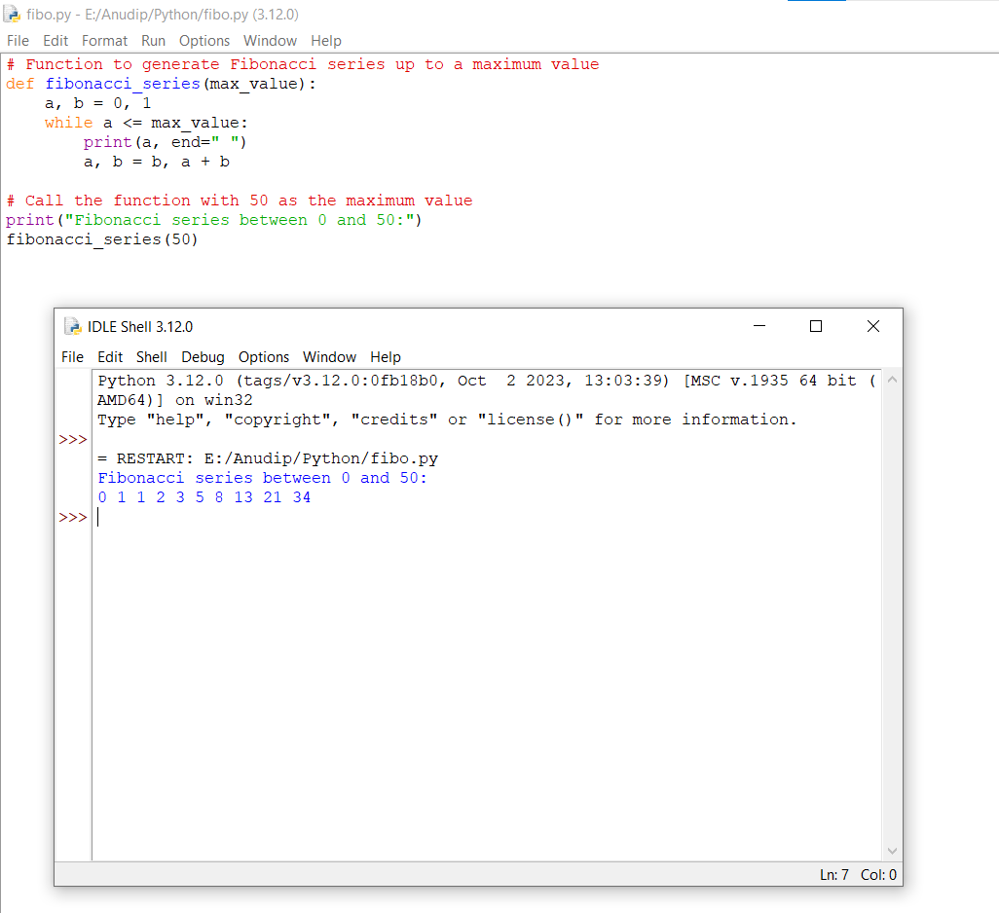

**Q5. Python program to check the validity of password input by users**

**Sol.**

